Radiation preparation of Y₂O₃ nanopowder

A. Jakub Kliment*,james256@centrum.cz; Supervisor: doc. Ing. Václav Čuba, Ph.D**,
vaclav.cuba@fjfi.cvut.cz

* High school Karla Sladkovského, Sladkovského náměstí 8, Prague 3, 13000
** CTU in Prague, Faculty of Nuclear Sciences and Physical Engeneering, Břehová 7, Prague 1, 11519

1. INTRODUCTION

1.1. Abstract
The interaction of ionizing and UV radiation with matter causes formation of ionized and excited states. The irradiation of solutions with convenient composition using different types of radiation may result in formation of amorphous or crystalline nanoparticles with narrow size distribution and high chemical purity.
The aim of this work was radiation induced preparation of crystalline yttrium oxide nanopowder from aqueous solutions using non-ionizing and ionizing radiation, evaluating the conditions of nanoparticle formation in the radiation field, separation and characterization of the product.

1.2.Yttrium oxide
Yttrium oxide is a highly insoluble thermally stable compound suitable for preparation of glass and ceramics and for optical applications. Ytrium oxide doped with various donor ions (e.g. Ce³⁺) could serve as a material for preparation of scintillators [1].

2. Experimental

2.1. Preparation of a samples
At first, aqueous solution of yttrium nitrate (5,22.10-3 mol/l) and ammonium formate (12.10-3 mol/l) was prepared. (We also tried to use potassium formate instead of ammonium formate, but it was less effective.) The irradiation was performed using ultraviolet lamp – radiation reduction of yttrium(III) ionts and reaction with oxygen occurred under irradiation.
After irradiation, the finely dispersed solid matter was separated via ultrafiltration and dried at 40 ̊ C.

2.2. Thermal analysis
Thermal analysis is a branch of materials science where the the changes of materials’ properties with the change of temperature are studied.

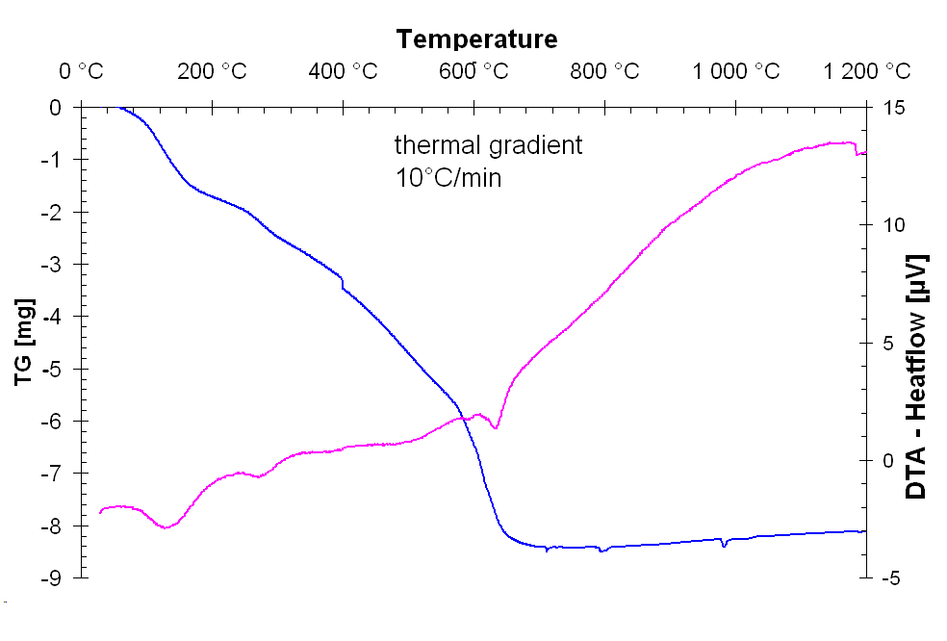

Fig. 1. TG / DTA curve of the prepared sample

It can be seen that at first, dehydratation of material occurs in temperature interval 80 – 200 °C. TG measurement suggests that solid phase forms probably due to interactions of HCOO⁻ anion present in irradiated solutions with products of water photolysis, namely with OH and H radicals.

2.3. X-Ray powder diffraction (XRPD)
When X-rays diffract at the right diffraction angle theta (unique for each material), their interference occurs. Therefore, the detector collects stronger impulses at certain angles, which are shown in diffractogram [2].
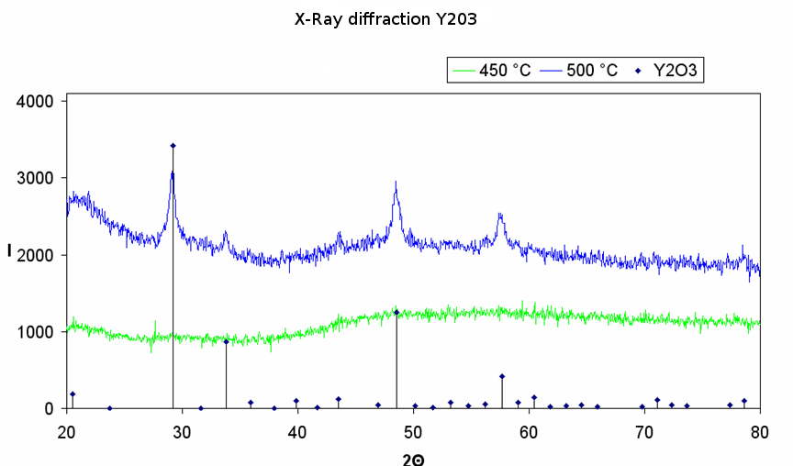

Fig. 2. Diffractogram of the samples treated at 450 and 500 ̊ C and figures from the database

The XRPD was studied with samples treated at temperatures of 450 and 500 ̊ C. A comparison with the database was performed. Although there are no recognizable diffraction lines of the sample treated at 450 ̊ C, the lines of the sample treated at 500 ̊ C, which are similar to the database, confirm that we achieved formation of yttrium oxide crystalline nanoparticles. This means that the lowest temperature required for Y₂O₃ crystals formation is between these temperatures.

2.4. Surface area
Specific surface area was determined with selective adsorption of nitrogen from its mixture with hydrogen at low temperatures on MSP apparatus.
The obtained result - 53.7 m2/g confirms that the prepared Y2O3 was nanomaterial.

2.5. Images of the sample
The sample of Y₂O₃ treated at 500 ̊ C consisted of regular monocrystalline grains with size about 100 nm. With the rising temperature of the post-irradiation treatment the size of yttrium oxide grains increased.

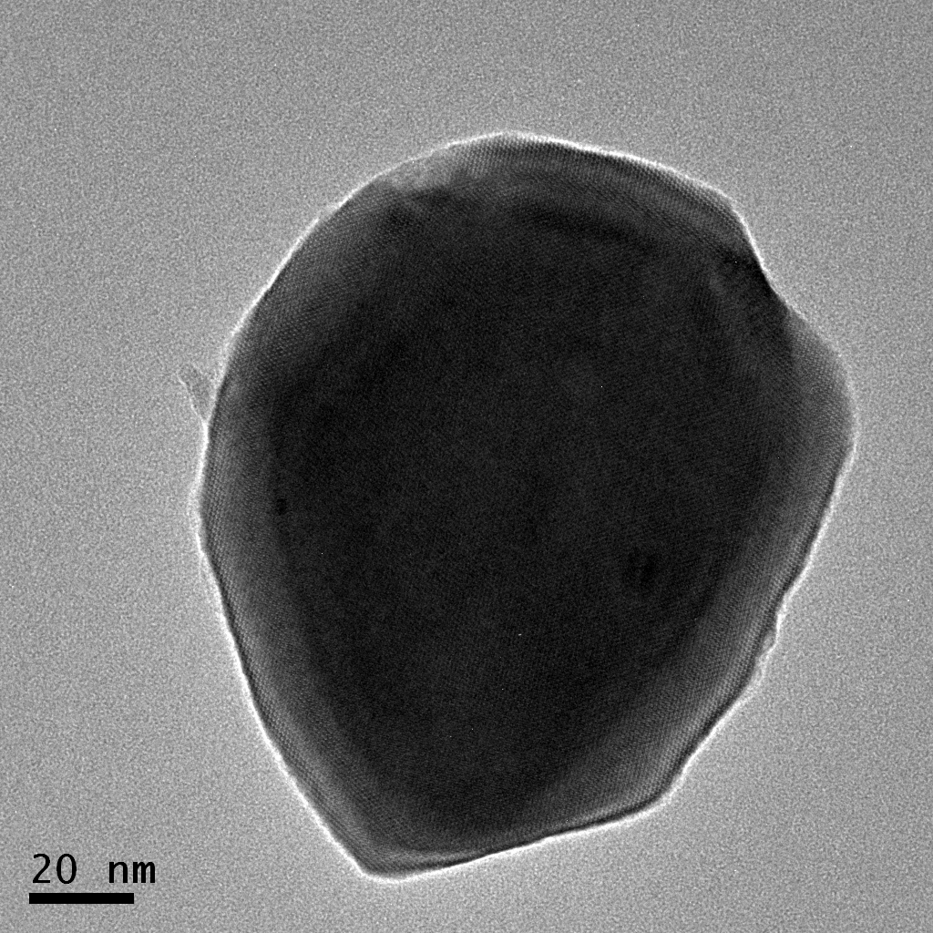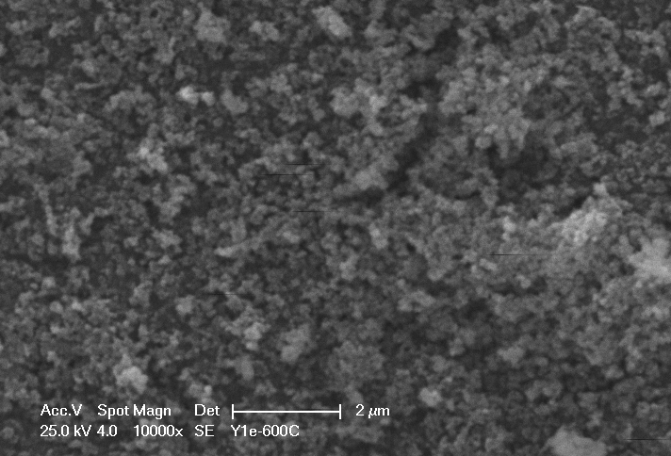

Fig. 3. TEM and SEM images of the sample treated at 500 ̊

3. Conclusions
Crystalline Y₂O₃ nanoparticles were successfully prepared by UV radiation induced synthesis. It was necessary to treat the amorphous phase formed during irradiation at higher temperature. Unlike other chemical methods of preparation in which temperatures between 600 and 800 ̊ C are required, the radiation induced synthesis requires only 500 ̊ C. After post-irradiation thermal treatment, the material consists of regular monocrystalline Y₂O₃ grains with size about 100 nm, with narrow size distribution. The material has an extremely large specific surface area (more than 50 m²/g), while the other chemical methods of preparation result in values between 10 and 60 m²/g [3].
We also successfully prepared homogenous tablet from the prepared powder under pressure of 10 MPa.
The radiation induced synthesis is promising for practical use – we have found it to be fast, effective and inexpensive.

Acknowledments
Thanks to the project “Cesta k vědě“ and CTU in Prague, Faculty of Nuclear Sciences and Physical Engeneering for all support.

References
[1] Wikipedia , Scintillator.
http://en.wikipedia.org/wiki/Scintillator
[2] MFF UK, X-Ray diffraction.
http://physics.mff.cuni.cz/vyuka/zfp/txt_421.pdf
[3] Yong-Nian Xu; Zhong-quan Gu; W. Y. Ching
(1997). Electronic, structural, and optical
properties of crystalline yttria.


Evropský sociální fond
Praha & EU: Investujeme do vaší budoucnosti

