DESIGN of the POLYMER PLANAR OPTICAL WAVEGUIDES for FTTH SYSTEM Dan Humpál, dan.humpal@gmail.com, Jan Píro, jpiro93@gmail.com, Gymnázium Christiana Dopplera

INTRODUCTION
Polymer planar optical waveguides has been studied as a replacement for now used glass, crystal or semiconductor based optical waveguides, due to their low cost, suitable properties and easy fabrication and manufacturing process. We have chosen Epoxy Novolak Resin and Norland Optical Adhesive polymer as waveguide layer because their optical abilities are more than adequate for passive optical components such as optical splitters and dividers.
DESIGN OF THE POLYMER OPTICAL WAVEGUIDES
The planar optical waveguides are composed of three different parts: a substratum, wave guiding layer and a covering layer. We decided to use ditch model of planar waveguide, as seen in Figure 1, due to the easy manufacturing process, which also means that we are using total reflection for spreading light thorough the waveguide.
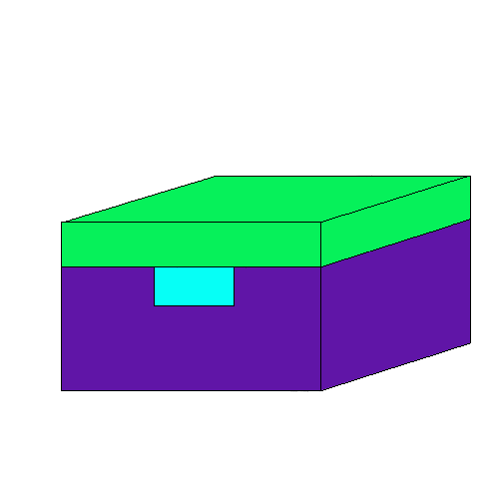
Fig. 1 scheme of planar optical waveguide
For achieving total reflection we needed to use wave guiding layer which had bigger index of refraction than the substratum and the covering layer. We tested four different polymers for their index of refraction in order to decide whether they can be used as a substratum or not. The measured indexes of refraction can be seen in Figure 2, which also shows that index of refraction depends on an actual wavelength. The possible substratum polymers are shown in a green hued colors and wave guiding layers in red hued colors. As a covering layer we have used the same polymer as substratum or just air. As seen in Figure 2 every optional combination of a substratum and wave guiding layer is possible for achieving total reflection.
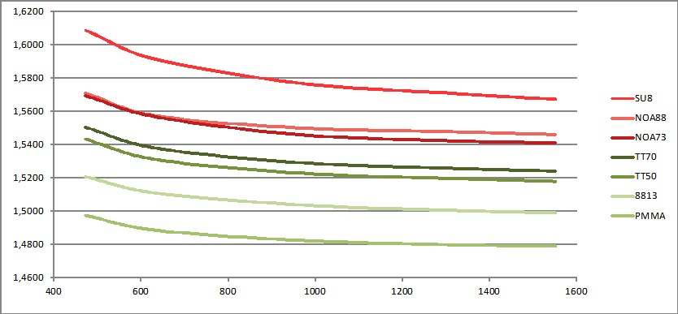
Fig. 3 measured refractive indexes depending on wavelength in nm
DESIGN OF THE OPTICAL 1x2 Y SPLITTER
The polymer 1x2 Y splitter is a passive optical part which symmetrically divides the power of the light into halves and leads in two different branches of light conductor as can be seen on Figure 3.
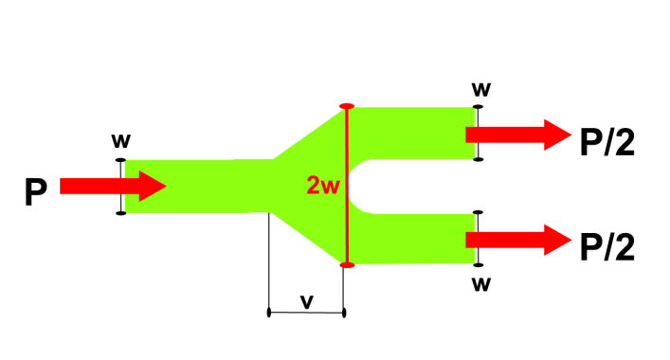
Fig. 3 The 1x2 Y optical splitter scheme
For the actual design, we used software by the Rsoft company, module called BeamPROP™, which uses am propagation method for simulating the propagation of light beam thorough the light conductor or, in our case, the optical 1x2 Y splitter. How the layout from this software and the simulation of the light beams propagation look like see Figure 4 and Figure 5. For time and computer time spare we have simulated the propagation in two dimensions only.
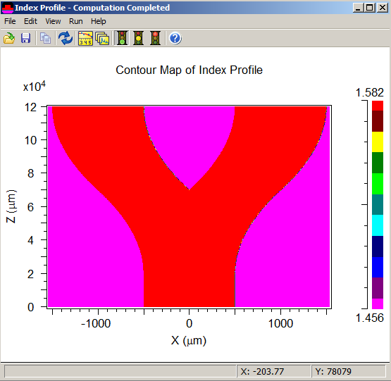
Fig. 4 BeamPROP™ index profile map
FABRICATION OF THE POLYMER OPTICAL WAVEGUIDES
We have narrowed all optional methods to three which have indicated the best abilities to be used in industrial manufacturing of optical parts. The first method uses a laser for drawing demanded pattern into a substratum. Then we considered the CNC method, which uses cutter for saw the expected pattern. And finally the imprinting which, up to now, have showed the best results. It consists using a plunger for imprinting the needed pattern into the substratum by force. In Figure 6 is shown an actual plunger and a sample of ditched substratum using this plunger.

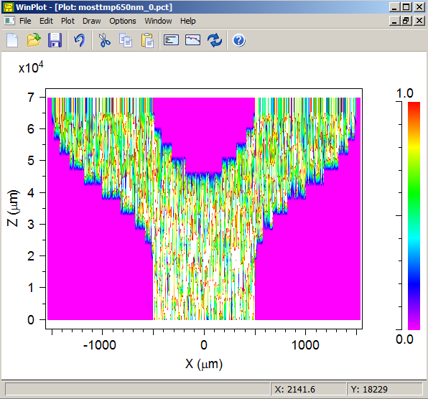
Fig. 5 BeamPROP™ beam propagation simulation
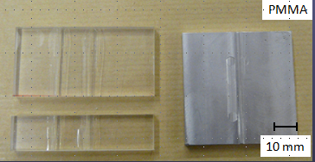
Fig. 6 substratum with imprinted pattern and a plunger
MEASURMENTS
For testing for different optical abilities of optical waveguides a lot of methods are used. We measured the samples using the Metricon system which uses “dark mode spectroscopy” method for measuring the modes of an optical waveguide. This method can be seen on scheme in Figure 7.
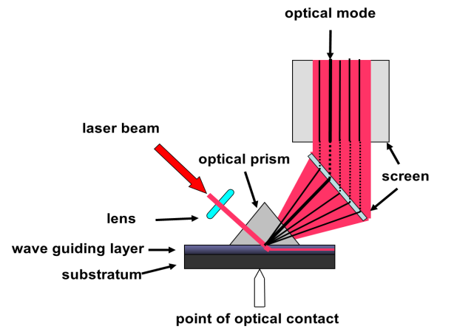
Fig. 7 dark mode spectroscopy scheme
We also used ellipsometry method for measuring the index of refraction of our samples.
PROPERTIES OF THE SAMPLE
Using these methods we have obtained data which indicate the optical properties of the sample. In Figure 8 and 9 we see two diagrams that tell us the optical properties of wave guiding polymer NOA88, which has been used as a wave guiding layer in our sample.
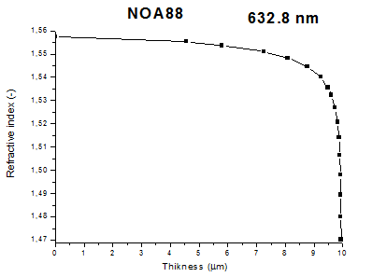
Fig. 8 properties of NOA88 on 632.8 nm wavelength
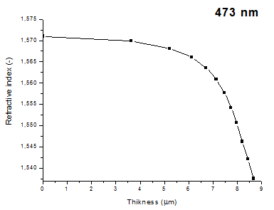
Fig. 9 properties of NOA88 on 473 nm wavelength
CONCLUSIONS
We have created samples of planar optical waveguides and planar optical 1x2 Y splitters, using polymers which have been chosen for their good optical abilities. Then we optimized the manufacturing process for best usage in industrial fabrication. They are cheaper and easier to create than presently used glass optical fibers. After testing they proved to have more than adequate optical properties for usage in Fiber to the Home system and creating passive optical parts such as optical splitters and dividers.
ACKNOWLEDGMENT: This work is part of project „Voyage to Science“ financed by Prague, the capital of Czech republic and European social fund, organized by Jaroslav Seifert´s grammar school. Many thanks to our supervizor, Ing. Václav Prajzler, PhD., Dep. of Microelectronics, FEE, CTU for his guidance and advices.
Evropský sociální fond
Praha & EU: Investujeme do vaší budoucnosti

